How to Connect to UR_Connected on Windows 10
- Ensure you have wireless enabled on your computer by clicking on the WiFi icon in the lower right hand corner of your desktop,
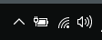
- Select “UR_Connected” click Connect.
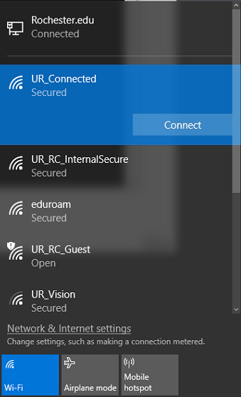
- Enter:
  - UR username
  - your domain account password
  - Then click OK.
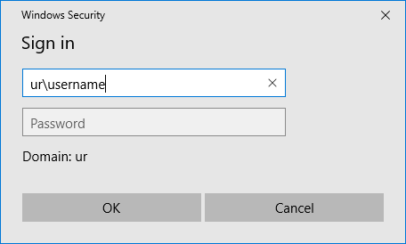
- Once you are connected, you will see a message under UR_Connected Connected, secured
